**COFFEE SALES SQL ANALYSIS RESULTS**

1. Viewing the table coffee_shop_sales

select * from coffee_shop_sales;

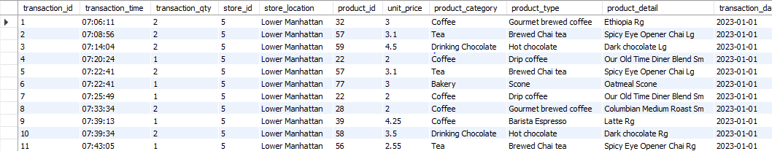

1. Changing data type to date and column

converting transaction_date into dd/mm/yy

UPDATE coffee_shop_sales

SET transaction_date = STR_TO_DATE(transaction_date, '%m-%d-%Y');

------------------------------------------------------------------

-- changing data type of transaction_date from text to date

ALTER TABLE coffee_shop_sales

MODIFY COLUMN transaction_date DATE;

-- The 2 above query threw an error as the date in the table does not match the MYSQL standard date format 'YYYY-MM-DD'.

-- So, I used following steps to solve the problem.

-- Step 1: Adding a temporary column

ALTER TABLE coffee_shop_sales

ADD COLUMN temp_transaction_date DATE;

-- Step 2: Update the temporary column with converted date values

UPDATE coffee_shop_sales

SET temp_transaction_date = STR_TO_DATE(transaction_date, '%m/%d/%Y');

-- Step 4: Drop the original column

ALTER TABLE coffee_shop_sales

DROP COLUMN transaction_date;

-- Step 5: Rename the temporary column to the original column name

ALTER TABLE coffee_shop_sales

CHANGE COLUMN temp_transaction_date transaction_date DATE;

select * from coffee_shop_sales;

describe coffee_shop_sales;

---------------------------------------------------------------------------

-- converting transaction_time into HH:MM:SS

UPDATE coffee_shop_sales

SET transaction_time = STR_TO_DATE(transaction_time, '%H:%i:%s');

--------------------------------------------------------------------

-- changing data type of transaction_time from text to time

ALTER TABLE coffee_shop_sales

MODIFY COLUMN transaction_time TIME;

-- viewing the data type of columns

describe coffee_shop_sales;

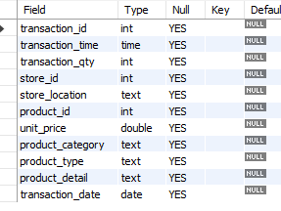

1. Finding total sales for any month

select * from coffee_shop_sales;

SELECT SUM((transaction_qty)*(unit_price)) as Total_Sales

FROM coffee_shop_sales

WHERE MONTH(transaction_date) = 5;

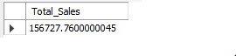

1. Finding monthly count increase in percentage

SELECT

MONTH(transaction_date) As month,

ROUND(COUNT(transaction_id)) AS Total_Orders,

(COUNT(transaction_id) - LAG(COUNT(transaction_id),1)

OVER (ORDER BY MONTH(transaction_date)))/LAG(COUNT(transaction_id),1)

OVER(ORDER BY MONTH(transaction_date))*100 as MonthlyIncreaseinOrders

FROM coffee_shop_Sales

WHERE MONTH(transaction_date) IN (4,5)

GROUP BY MONTH(transaction_date)

ORDER BY MONTH(transaction_date);

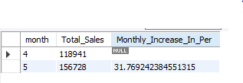

1. Finding total quantity sold in particular month

select * from coffee_shop_sales;

SELECT SUM(transaction_qty) as Total_Qty_Sold

FROM coffee_shop_sales

WHERE MONTH(transaction_date)=5;

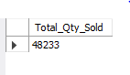

1. Finding total sales, total quantity sold and total orders in a particulat date

SELECT

MONTH(transaction_date) As month,

ROUND(SUM(transaction_qty)) AS Total_Orders,

(SUM(transaction_qty) - LAG(SUM(transaction_qty),1)

OVER (ORDER BY MONTH(transaction_date)))/LAG(SUM(transaction_qty),1)

OVER(ORDER BY MONTH(transaction_date))*100 as MonthlyIncreaseinQuantity

FROM coffee_shop_Sales

WHERE MONTH(transaction_date) IN (4,5)

GROUP BY MONTH(transaction_date)

ORDER BY MONTH(transaction_date);



1. Total Sales, Total Quantity Sold and Total orders for particular date

SELECT

CONCAT(ROUND(SUM(unit_price*transaction_qty)/1000,1),'k') As Total_Sales,

CONCAT(ROUND(SUM(transaction_qty)/1000,1),'k') As Total_Qty_Sold,

CONCAT(ROUND(COUNT(transaction_id)/1000,1),'k') as Total_Orders

FROM coffee_shop_Sales

WHERE transaction_date='2023-05-18'

;

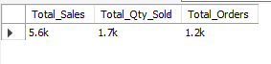

1. Sales analysis by weekdays and weekends

Weekends - Sat-Sun

Weekdays - Mon-Fri

SELECT

CASE

WHEN DAYOFWEEK(transaction_date) IN (1,7) THEN 'Weekends'

ELSE

'Weekdays'

END AS Day_Type,

CONCAT(ROUND(SUM(unit_price*transaction_qty)/1000,1),'k') AS TotalSales

FROM coffee_Shop_sales

WHERE MONTH(transaction_date)=5

GROUP BY

CASE

WHEN DAYOFWEEK(transaction_date) IN (1,7) THEN 'Weekends'

ELSE

'Weekdays'

END

;



1. Total Sales by store location in particular month

SELECT

store_location,

CONCAT(ROUND(SUM(unit_price*transaction_qty)/1000,2),'k') as TotalSales

FROM coffee_shop_sales

WHERE MONTH(transaction_date)=5

GROUP BY store_location

ORDER BY SUM(unit_price*transaction_qty) desc ;

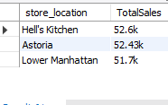

1. Average sales in a particular month

SELECT

AVG(total_Sales) as AverageSales

FROM

(

SELECT SUM(unit_price*transaction_qty) as Total_Sales

FROM

coffee_Shop_Sales

WHERE

MONTH(transaction_date)=5

GROUP BY transaction_date

) as InnerQuery

;

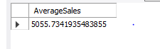

1. Daily sales for particular month

SELECT

DAY(transaction_date) as Day_Of_Month,

CONCAT(ROUND(SUM(unit_price*transaction_qty)/1000,1),'k') as TotalSales

FROM coffee_shop_sales

WHERE MONTH(transaction_date)=5

GROUP BY DAY(transaction_date)

ORDER BY DAY(transaction_date);

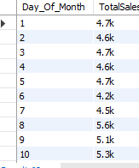

1. Finding if total sales is below average or above average

SELECT

CASE

WHEN total_Sales>avg_sales THEN 'Above Average'

WHEN total_Sales<avg_sales THEN 'Below Average'

ELSE 'Average'

END as Sales_Status,

total_sales

FROM

(

SELECT

DAY(transaction_date) as Day_of_Month,

SUM(unit_price*transaction_qty) as Total_Sales,

AVG(SUM(unit_price*transaction_qty)) OVER () AS AVG_SALES

FROM

COFFEE_SHOP_SALES

WHERE MONTH(transaction_date)=5

group by

DAY(transaction_date)

) as Sales_data

ORDER BY

day_of_month;

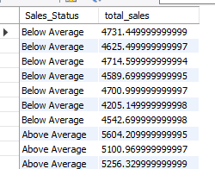

1. Sales by product category for particular month

SELECT product_category,SUM(unit_price*transaction_qty) as TotalSales

FROM coffee_shop_sales

WHERE MONTH(transaction_date)=5

GROUP BY

product_category;

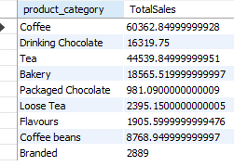

1. Total sales, Total quantity and Total order for particular hour, day and month

SELECT CONCAT(ROUND(SUM(unit_price*transaction_qty)/1000,1),'k') as TotalSales,

SUM(transaction_qty) as Total_qty_sold,

COUNT(*) as TotalOrders

FROM coffee_shop_sales

WHERE MONTH(transaction_date)=5

AND

DAYOFWEEK(transaction_date)=2

AND

HOUR(transaction_time)=8

;

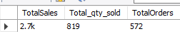

1. Total sales by hour in a particular month

SELECT HOUR(transaction_time) as hourofday,

SUM(unit_price*transaction_qty) as TotalSales

FROM coffee_shop_sales

WHERE MONTH(transaction_date)=5

GROUP BY HOUR(transaction_time)

ORDER BY HOUR(transaction_time);

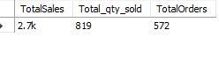

1. Total Sales by days in a particular month

SELECT

CASE

WHEN DAYOFWEEK(transaction_date)=2 THEN 'Monday'

WHEN DAYOFWEEK(transaction_date)=3 THEN 'Tuesday'

WHEN DAYOFWEEK(transaction_date)=4 THEN 'Wednesday'

WHEN DAYOFWEEK(transaction_date)=5 THEN 'Thursday'

WHEN DAYOFWEEK(transaction_date)=6 THEN 'Friday'

WHEN DAYOFWEEK(transaction_date)=7 THEN 'Saturday'

ELSE 'Sunday'

END AS Day_of_week,

ROUND(SUM(unit_price*transaction_qty)) as Total_Sales

FROM

coffee_shop_sales

WHERE MONTH(transaction_date) =5

GROUP BY

CASE

WHEN DAYOFWEEK(transaction_date)=2 THEN 'Monday'

WHEN DAYOFWEEK(transaction_date)=3 THEN 'Tuesday'

WHEN DAYOFWEEK(transaction_date)=4 THEN 'Wednesday'

WHEN DAYOFWEEK(transaction_date)=5 THEN 'Thursday'

WHEN DAYOFWEEK(transaction_date)=6 THEN 'Friday'

WHEN DAYOFWEEK(transaction_date)=7 THEN 'Saturday'

ELSE 'Sunday'

END

;

